Xytech Enables SES to Seamlessly Merge Two Resource Management Systems into One

World’s leading content connectivity solutions provider completes transition to future-proof Xytech system

London, UK, November 2, 2021 — SES, the leader in global content connectivity solutions, has implemented a new resource management platform using Xytech solutions, Xytech announced today. The new platform consolidates two systems previously used by SES into a single comprehensive solution to maximize the operational efficiency and simplify the capacity booking processes for SES’s sports and events customers.
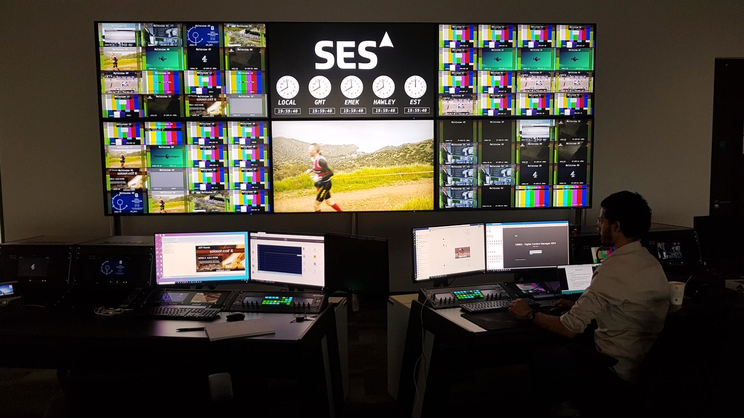
The newly-launched platform offers SES and its customers, such as media companies, sports organisations and rights holders, workflow control with schedule-once efficiency, intelligent conflict management as well as long-term and recurring bookings, allowing for swift and effective resource management.

“Thanks to the support we received from Xytech’s team, the transition of merging both platforms was smooth with no impact to our operations,” adds Ed Cox, Vice President, Sales North America and Sports & Events at SES. “Through a great deal of dialogue, complete definition of our requirements and out-of-the-box thinking from both sides, we achieved a unified platform that ultimately simplifies capacity booking process for our customers.”

“We’ve enjoyed a great relationship with SES for over a decade and this is the lastest in a series of projects we’ve successfully completed,” states Greg Dolan, CCO of Xytech. “Combining these systems in a timely and efficient manner not only allows SES to better meet their clients demands today, but sets the stage for future upgrades to better serve their customers tomorrow.”

Hi res image available for download from https://gasolinemedia.jalbum.net/Xytech_SES/

About Xytech
For more than 30 years, the world’s premiere media companies have depended on Xytech to run their businesses. MediaPulse is the only end-to-end solution for the complete content lifecycle. MediaPulse provides scheduling, automation, asset management, billing and cost recovery for broadcasters, media services companies and transmission facilities in a scalable platform-independent solution. In April 2021, Xytech acquired the ScheduALL brand of enterprise resource management software for broadcasters and media companies, providing end-users with an even more robust product roadmap and greater global service offerings. For more information, visit xytechsystems.com.

Media Contacts:

Sarah James
Gasoline Media
+44 7702 421635
sarahj@gasolinemedia.com

Victoria Chernih
Gasoline Media
+44 7881 091687
victoria@gasolinemedia.com

